**PIZZA SALES SQL QUERIES**

**A. KPI’s**

**1. Total Revenue:**

select sum(total_price) as Total_Revenue from pizza_sales

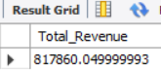

**2. Average Order Value**

select sum(total_price)/count(distinct order_id) as Average_Order_Value

from pizza_sales

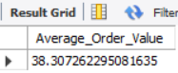

**3. Total Pizzas Sold**

select sum(quantity) as Total_Pizza_Sold from pizza_sales

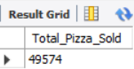

**4. Total Orders**

select count(distinct order_id) as Total_Orders from pizza_sales

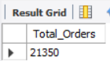

**5. Average Pizzas Per Order**

select round(sum(quantity)/count(distinct order_id),2) as Average_Pizza_Sold from pizza_sales

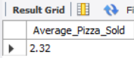

**B. Daily Trend for Total Orders**select dayname(order_date) as Day_Name, count(distinct order_id) as Total_Orders from pizza_sales

group by Day_Name

order by Total_Orders desc

***Output:***

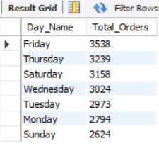

**C. Hourly Trend for Orders**

select hour(order_time) as Hour_, count(distinct order_id) as Total_Orders from pizza_sales

group by Hour_

order by Hour_

***Output***

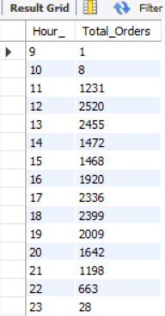

**% of Sales by Pizza Category**

select pizza_category, cast(sum(total_price) as decimal(10,2)) as Total_Revenue,

cast(sum(total_price)*100/(select sum(total_price) from pizza_sales) as decimal(10,2)) as Percent_Of_Total

from pizza_sales

group by pizza_category

***Output***

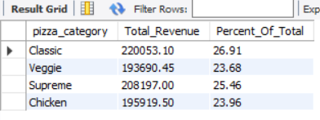

**E. % of Sales by Pizza Size**

select pizza_size, cast(sum(total_price) as decimal(10,2)) as Total_Revenue,

cast(sum(total_price)*100/(select sum(total_price) from pizza_sales) as decimal(10,2)) as Percent_Of_Total

from pizza_sales

group by pizza_size

order by Percent_Of_Total desc

***Output***

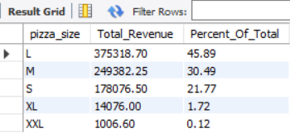

**F. Total Pizzas Sold by Pizza Category**

select pizza_category, Sum(quantity) as Total_Pizzas_Sold

from pizza_sales

group by pizza_category

order by Total_Pizzas_Sold desc

***Output***

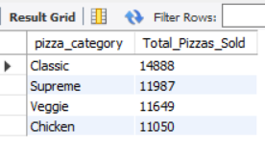

**G. Top 5 Best Sellers by Total Pizzas Sold**

select Pizza_name, Sum(quantity) as Total_Pizzas_Sold

from pizza_sales

group by Pizza_name

order by Total_Pizzas_Sold desc

limit 5

***Output***

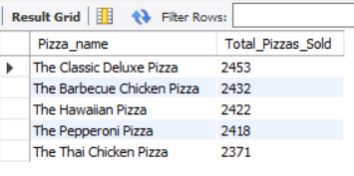

**H. Bottom 5 Best Sellers by Total Pizzas Sold**

SELECT TOP 5 pizza_name, SUM(quantity) AS Total_Pizza_Sold

FROM pizza_sales

GROUP BY pizza_name

ORDER BY Total_Pizza_Sold ASC

***Output***

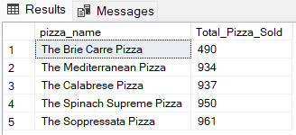

***NOTE***

If you want to apply the Month, Quarter, Week filters to the above queries you can use WHERE clause. Follow some of below examples

select dayname(order_date) as Day_Name , count(distinct order_id) as Total_Orders from pizza_sales

where month(order_date) = 1

group by Day_Name

order by Total_Orders desc

*\*Here MONTH(order_date) = 1 indicates that the output is for the month of January. MONTH(order_date) = 4 indicates output for Month of April.*

select dayname(order_date) as Day_Name, count(distinct order_id) as Total_Orders from pizza_sales

where quarter(order_date) = 1

group by Day_Name

order by Total_Orders desc;

*\*Here DATEPART(QUARTER, order_date) = 1 indicates that the output is for the Quarter 1. MONTH(order_date) = 3 indicates output for Quarter 3.*